Online Group Activity Facilitator Guide
- Create Your Activity
  - We use Google Drawings for card sorts, jigsaws, escape puzzles and more
  - To create a new Google Drawing, go to your Google Drive and click “+ New” in the top left corner. Hover over More > and select Google Drawings
  - For directions on how to build these activities visit the UF Instructor Guide
- Make a Copy of the Activity to Use As a “Master Copy”
  - With the Google Drawing open, click File > Make a Copy
- Configure the Share Settings of Your Activity
  - Click File > Share
  - Click “Get Shareable Link”
  - Make sure dropdown says “Anyone with link can edit”
- Have All Students Create a UF Google Account
  - How to Create a UF Google Account
- Choose a Group Facilitator
- Create Breakout Rooms in Zoom
  - In the breakout room options, set the countdown timer to 30 seconds or less
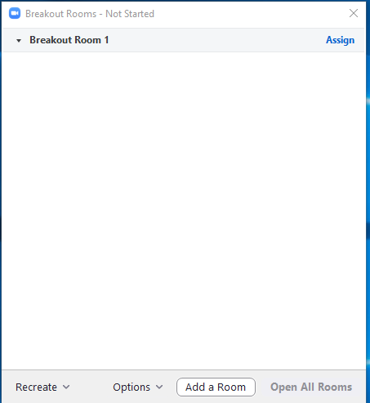
- Place the link to the Google activity in the chat
- Instruct Facilitator to click on the activity link in the chat and make a copy of the activity
- Facilitator makes a copy for his/her/their group
- Facilitator shares a link to the copy in the chat
- All group members can:
  - move cards in the Google drawing
  - read the articles
  - solve the puzzle challenges

